OBJECT ORIENTED PROGRAMMING USING JAVA

NAME : P.R.DHANVIN

DEPT & SEC : CSE & B

ROLL NO: 230701071

WEEK : 12

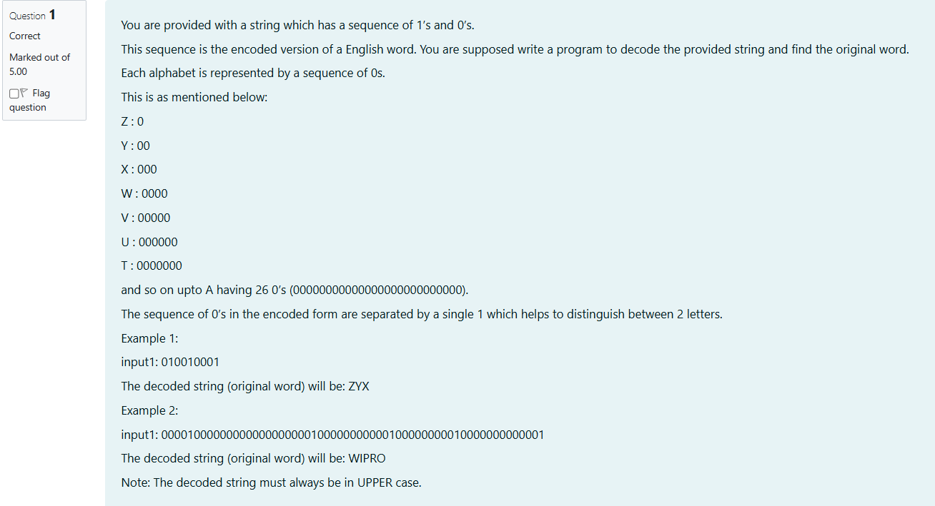

import java.util.Scanner;

public class Decoder {

public static String decode(String input) {

String[] zeroSequences = input.split("1");

StringBuilder decodedWord = new StringBuilder();

for (String zeros : zeroSequences) {

int zeroCount = zeros.length();

if (zeroCount > 0 && zeroCount <= 26) {

char letter = (char) ('Z' - zeroCount + 1);

decodedWord.append(letter);

}

}

return decodedWord.toString();

}

public static void main(String[] args) {

Scanner scanner = new Scanner(System.in);

String input = scanner.nextLine();

System.out.println(decode(input));

scanner.close();

}

}

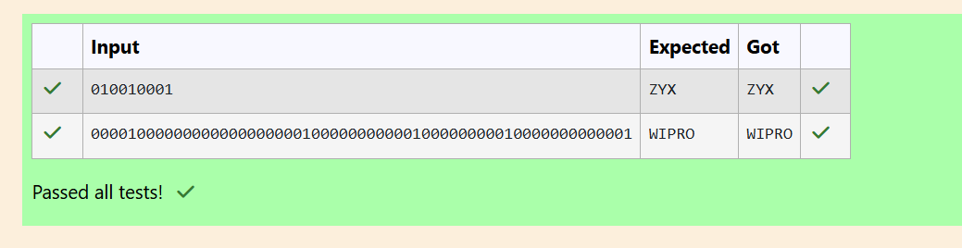

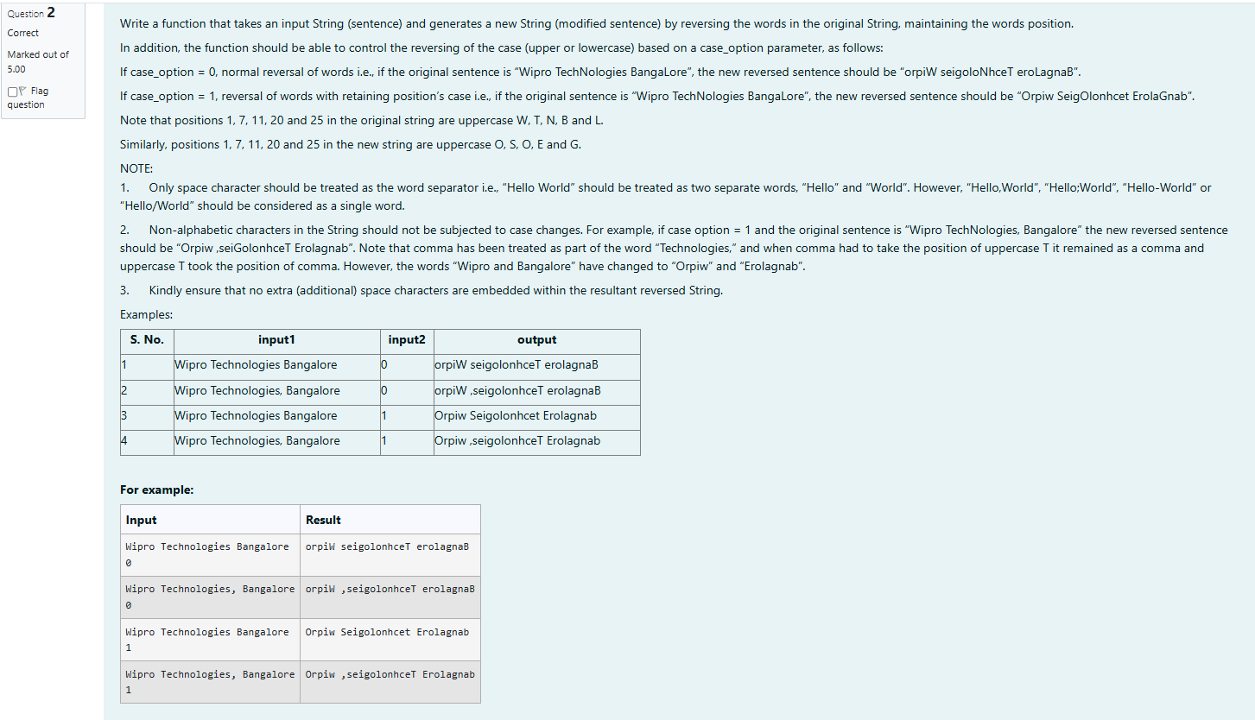  
import java.util.Scanner;

public class WordReversal {

public static void main(String[] args) {

Scanner sc = new Scanner(System.in);

String sentence = sc.nextLine();

int caseOption = sc.nextInt();

// Generate and display the modified sentence

String result = reverseWords(sentence, caseOption);

System.out.println(result);

sc.close();

}

public static String reverseWords(String sentence, int case_option) {

String[] words = sentence.split(" ");

StringBuilder modifiedSentence = new StringBuilder();

for (int i = 0; i < words.length; i++) {

String word = words[i];

StringBuilder reversedWord = new StringBuilder();

for (int j = word.length() - 1; j >= 0; j--) {

reversedWord.append(word.charAt(j));

}

if (case_option == 1) {

for (int j = 0; j < word.length(); j++) {

char originalChar = word.charAt(j);

char reversedChar = reversedWord.charAt(j);

if (Character.isUpperCase(originalChar)) {

reversedWord.setCharAt(j, Character.toUpperCase(reversedChar));

} else if (Character.isLowerCase(originalChar)) {

reversedWord.setCharAt(j, Character.toLowerCase(reversedChar));

}

}

}

modifiedSentence.append(reversedWord);

if (i < words.length - 1) {

modifiedSentence.append(" ");

}

}

return modifiedSentence.toString();

}

}

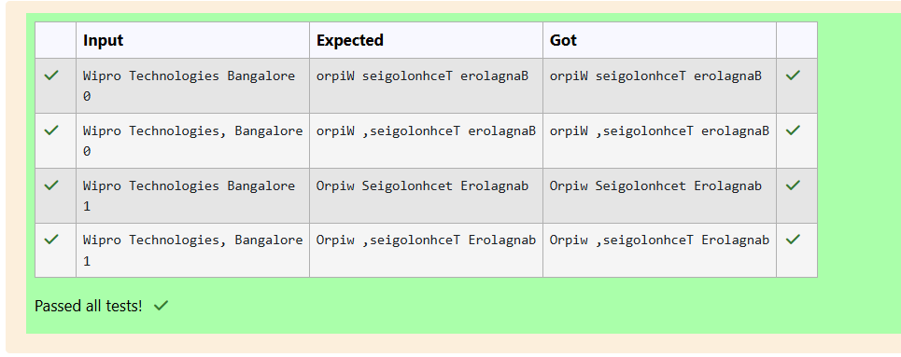

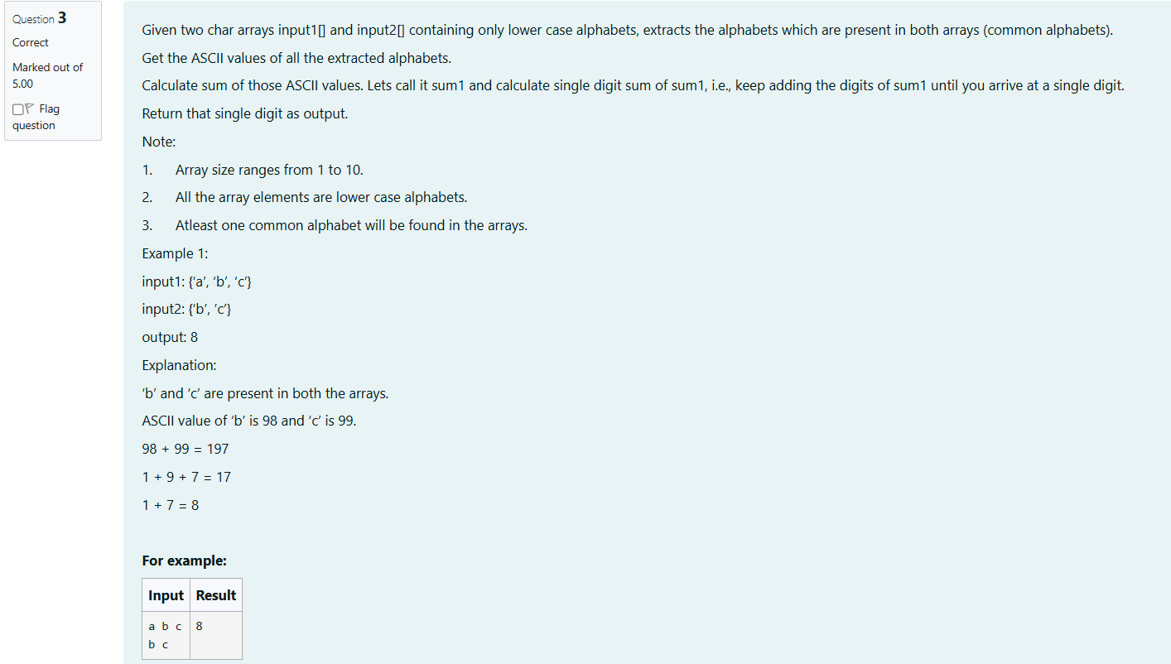

import java.util.Scanner;

public class CommonAlphabets {

public static int getSingleDigitSum(int sum) {

while (sum >= 10) {

sum = sumOfDigits(sum);

}

return sum;

}

public static int sumOfDigits(int number) {

int sum = 0;

while (number > 0) {

sum += number % 10;

number /= 10;

}

return sum;

}

public static int calculateCommonAlphabetSum(char[] input1, char[] input2) {

int sum1 = 0;

for (int i = 0; i < input1.length; i++) {

for (int j = 0; j < input2.length; j++) {

if (input1[i] == input2[j]) {

sum1 += (int) input1[i];

}

}

}

return getSingleDigitSum(sum1);

}

public static void main(String[] args) {

Scanner scanner = new Scanner(System.in);

String input1Str = scanner.nextLine();

char[] input1 = input1Str.replace(",", "").toCharArray();

String input2Str = scanner.nextLine();

char[] input2 = input2Str.replace(",", "").toCharArray();

int result =calculateCommonAlphabetSum(input1, input2);

result-=1;

System.out.println(result);

}

}

